18BCE0909 – NAVYA VERMA

The task assigned to me, was to remove ethnic, gender and racial bias in the text.

Analyzing written text for gender, racial and ethnic bias, with the intention of removing it, can prove to be highly complicated task, as it not only includes rectifying the whole text for explicit words or phrases that are biased in one of these ways, but also to modify or replace the specific words that are stereotyped with a specific gender, race or ethnic background. For example, words like “basketball” or “receptionist” are gender-neutral, but basketball is considered to be more closely related to males, while receptionist to females. This is a stereotyped, indirect bias, which may sometimes need to be addressed, while sometimes not.
If bias removal is applied to the written text, it may most of the times entirely change the vocabulary domain of the entire text document. For example, “salesman”, “chairman” would become “salesperson”, ”chairperson”. Most of the times, this may not be in the best interest of the context of the document.
Removing ethnic, gender or racial bias is an extremely advanced natural language processing task, and requires a greater skill set, and learning of the subject. In addition, bias removal may do more harm to the text, than good.
I researched about removing bias, though, and I found the following:
I am going to use the term Word Embeddings here, which is actually a way of presenting vocabulary. They are vector representative of words, where the spatial closeness determines the similarity or context between words.

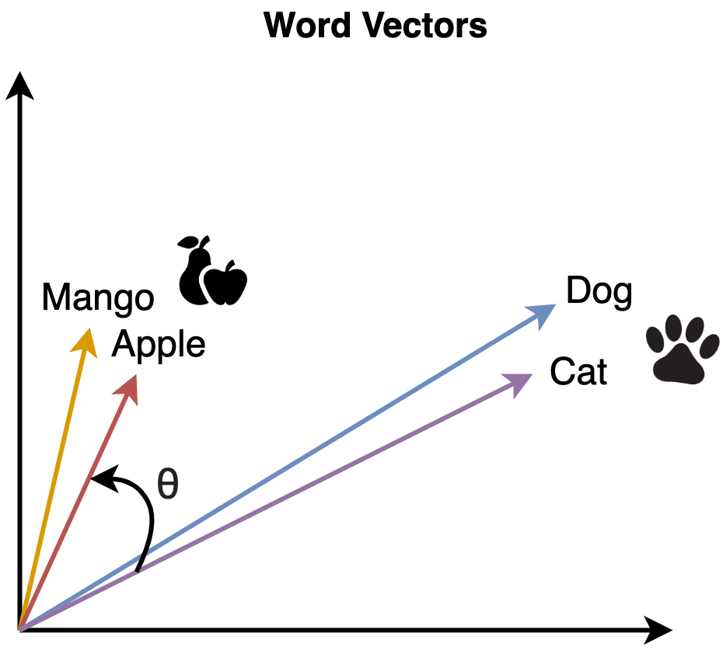
‘Dog’ and ‘Cat’ are closer to each other since both of them represent animals, whereas, ‘Mango’ and ‘Apple’ are closer to each other since they represent fruits. On the contrary, both the groups are far away from each other since they are not similar to each other.
The purpose can be achieved through the Word Embedding model, Word2Vec.
The similarity between the two words, can be determined by the following:

As I mentioned before, words like ‘receptionist’ are much closely related to females while ‘basketball’ is closer to males. This is called direct bias. There are also numerous cases, where the bias is not direct, but rather known via linking advanced features, known as indirect bias. Words like ‘bookkeeper’ are much closer to ‘softball’ than ‘basketball’ that may result indirectly from female associations with 'bookkeeper', 'receptionist' and 'softball'.

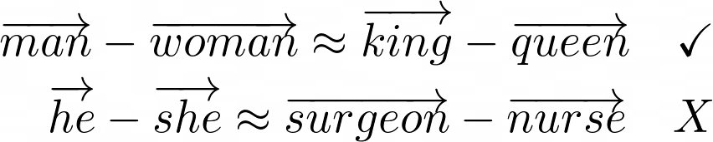
Here, the man:king and woman:queen is right, because it’s a rule of the nature, and the language. While stereotyping a male with being a surgeon, and the female being a nurse is absolutely wrong. Vector distance between males and surgeons is same as females and nurses, indicating direct gender bias.
Now I will reference Bolukbasi et al.’s paper, “Man is to Computer Programmer as Woman is to Homemaker? Debiasing Word Embeddings” (NIPS 2016) to depict the removal of gender bias.
The process is divided into three steps:
- Identifying Gender Subspace
A word embedding consists of hundreds of dimensions. To remove the gender bias, we first need to identify the dimension (also called subspace) or dimensions (there can be more than one dimension) where the bias is captured in the embedding.
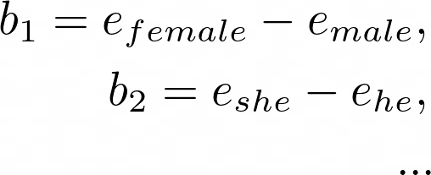

We first take the difference between sets of word embeddings (denoted by e) which define the concept of gender (e.g. ‘male’ & ‘female’, ‘he’ and ‘she’, etc.). Then, the bias subspace is calculated by taking the SVD of these differences. One simpler way, intuitively, is taking the average of the differences to broadly capture gender.

- Neutralize
After obtaining the bias direction b, we’ll remove the bias components from all gender-neutral words like receptionist and surgeon by subtracting the embedding’s projection onto the bias axis b (using the dot product of e & b).

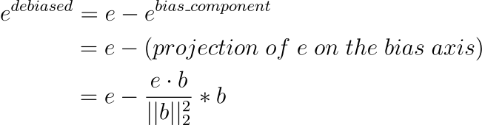

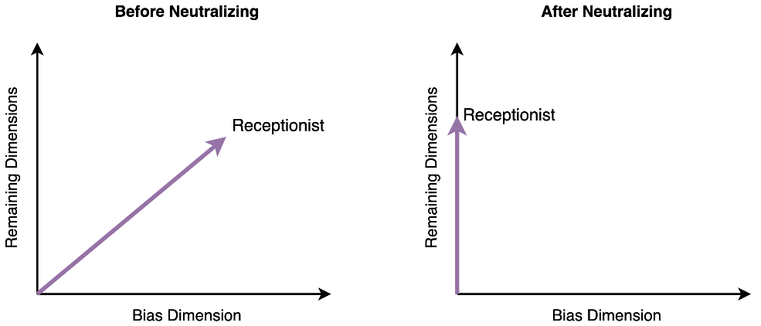

- Equalize
For the final step, we take care of the gender-specific words. Words like boy and girl should differ by gender equally i.e. the word ‘boy’ should not be any more masculine as the word ‘girl’ is feminine.
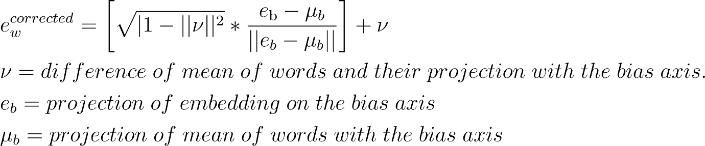

Intuition — For every gender-specific word, we equalize their vector lengths, such that, the gender component is preserved with equal strength in all pairs of words. Furthermore, it enforces that all gender-neutral words are equidistant from gender-specific words. E.g. receptionist is equidistant from boy and girl

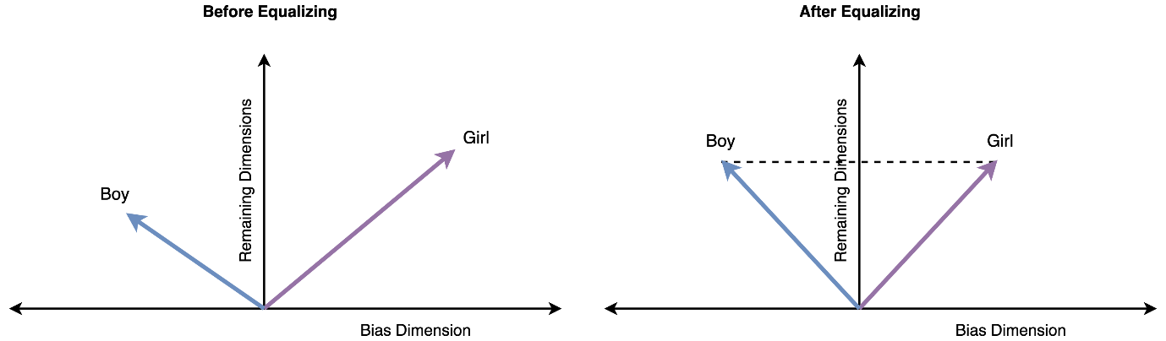

Thus, we see that Bias Removal is a highly advanced technique in Natural Language Processing, and is out of scope regarding the context and syllabus of our college course.

